Experiment 8
Employee Search Using an Array of
Objects
Problem Statement

Write a Java program to store employee details including employee number, name, and
salary, and search for an employee by employee number
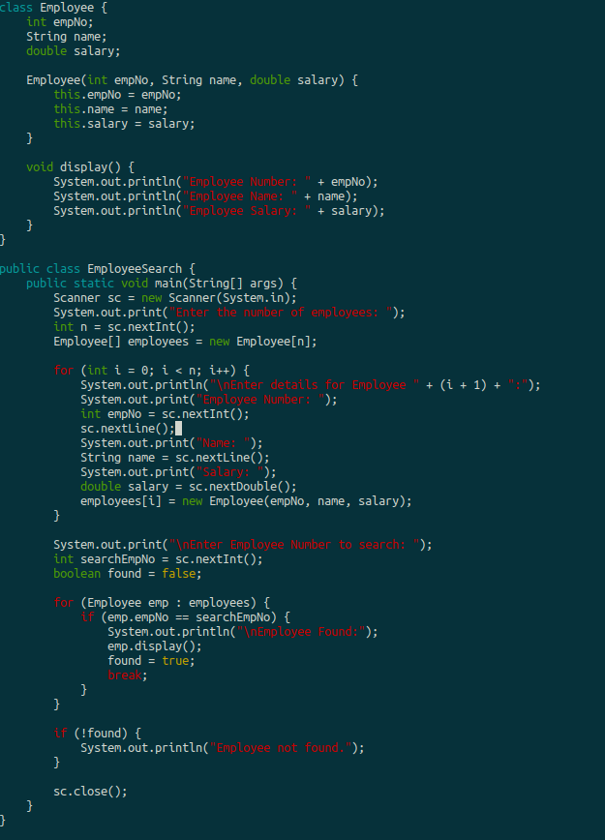

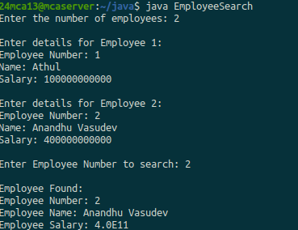

Experiment 9

String Search in an Array
Problem Statement

Write a Java program to store ‘n‘ strings in an array. Search for a given string. If found,
print its index; otherwise, display ”String not found.”
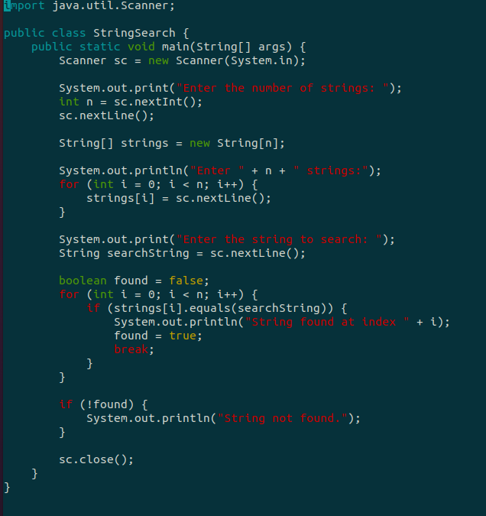

OUTPUT

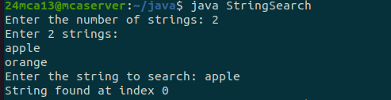
Experiment 10
String Manipulations
Problem Statement

Write a Java program to perform various string manipulations, including nding the
length, converting to uppercase and lowercase, extracting characters and substrings, and
reversing the string.

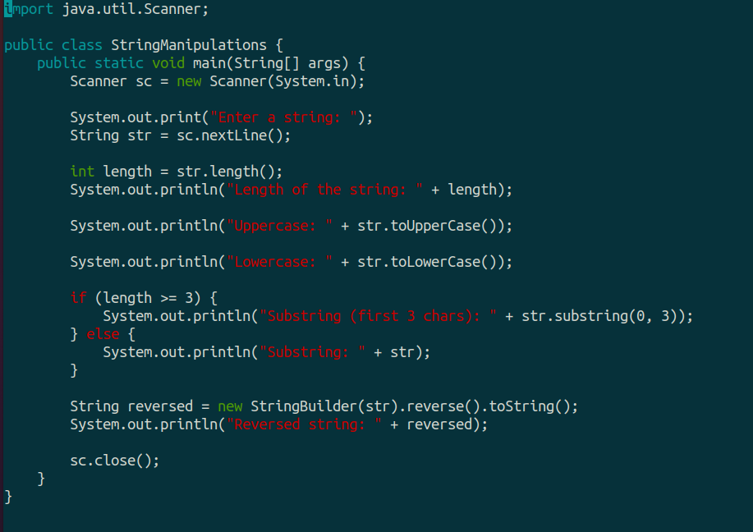

OUTPUT

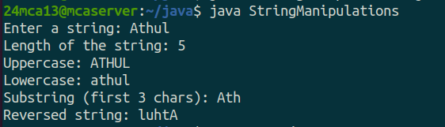

Experiment 11

Inheritance in Java
Problem Statement

Write a Java program to implement hierarchical inheritance for a book management
system. Dene a base class ‘Publisher‘, a derived class ‘Book‘, and two subclasses ‘Liter-
ature‘ and ‘Fiction‘. Include methods to read and display book details and demonstrate
the functionality using user input.
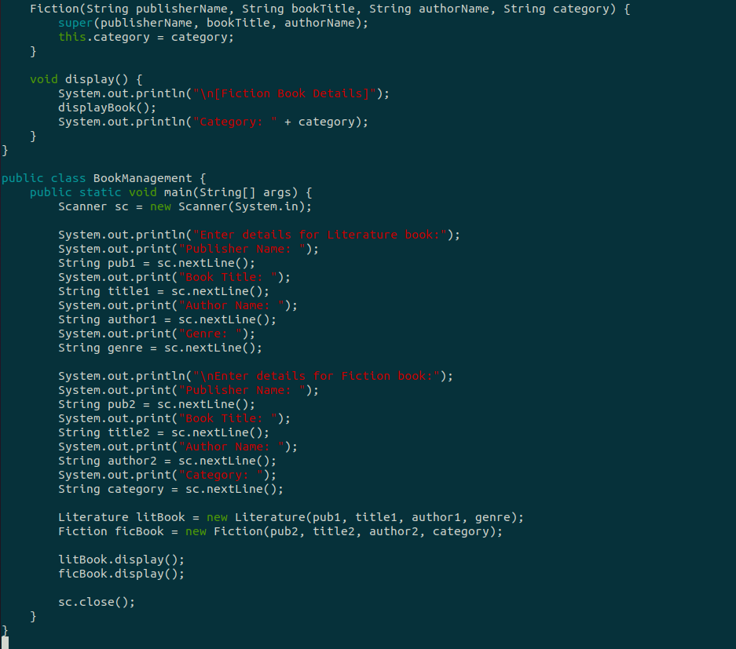

OUTPUT

